(ESP32-Eth-WiFi/LAN8720/OLED/DHT11/Buzzer)

(DuPont Connector)

|  |  |  |  |
| --- | --- | --- | --- |
| *GPIO* | *LAN8720 Top* | *Wire/DuPont* | *Function* |
| GPIO22 | TX1 (TXD1) | 1 White | RMII Transmit Data 1 |
| GPIO21 | TX_EN | 2 Blue | RMII Transmit Enable |
| GPIO25 | RX0 (RXD0) | 3 Yellow | RMII Receive Data 0 |
| GPIO17 | nINT/RETCLK | Not connected | CLK_OUT (ignored — LAN8720 has 50 MHz crystal) |
| GPIO18 | MDIO | 4 Green | MDIO Data |
| GND | GND | 5 Black | Common ground |
| 3.3V | VCC | 6 Red | Power LAN8720 (do NOT use 5V) |
| *GPIO* | *LAN8720 Bottom* | *Wire/DuPont* | *Function* |
| None | (not connected) | N/C | N/C |
| GPIO19 | TX0 (TXD0) | 7 Blue | RMII Transmit Data 0 |
| GPIO26 | RX1 (RXD1) | 8 Green | RMII Receive Data 1 |
| GPIO27 | CRS/DV | 9 White | RMII Carrier Sense / Data Valid |
| GPIO23 | MDC | 10 Yellow | MDIO Clock |
| GND | (not connected) | N/C | N/C |
| 3.3V | (not connected) | N/C | N/C |
| *GPIO* | *OLED/LCD2004* | *Wire/DuPont* | *Function* |
| GND | GND | Black | Common ground |
| 3.3V | VCC | Red | Power (do NOT use 5V) |
| GPIO32 | SCL | 4 Green |  |
| GPIO33 | SDA | 7 Blue |  |
| *GPIO* | DHT11 | *Wire/DuPont* | *Function* |
| GND | GND | Black | Common ground |
| 3.3V | VCC | Red | Power (do NOT use 5V) |
| GPIOXX | OUT | 10 Yellow |  |
| *GPIO* | Relay 5V | *Wire/DuPont* | *Function* |
| GND | DC- | Black | Common ground |
| 5V | DC+ | Red | Power (do NOT use 5V) |
| GPIOXX | IN | 10 Yellow | NO/COM are used to connect to the door opener |
| *GPIO* | Buzzer/Beep | *Wire/DuPont* | *Function* |
| GND | GND | Black | Common ground |
| 3.3V | VCC | Red | Power (do NOT use 5V) |

*(The following page contains picture of each component.)*

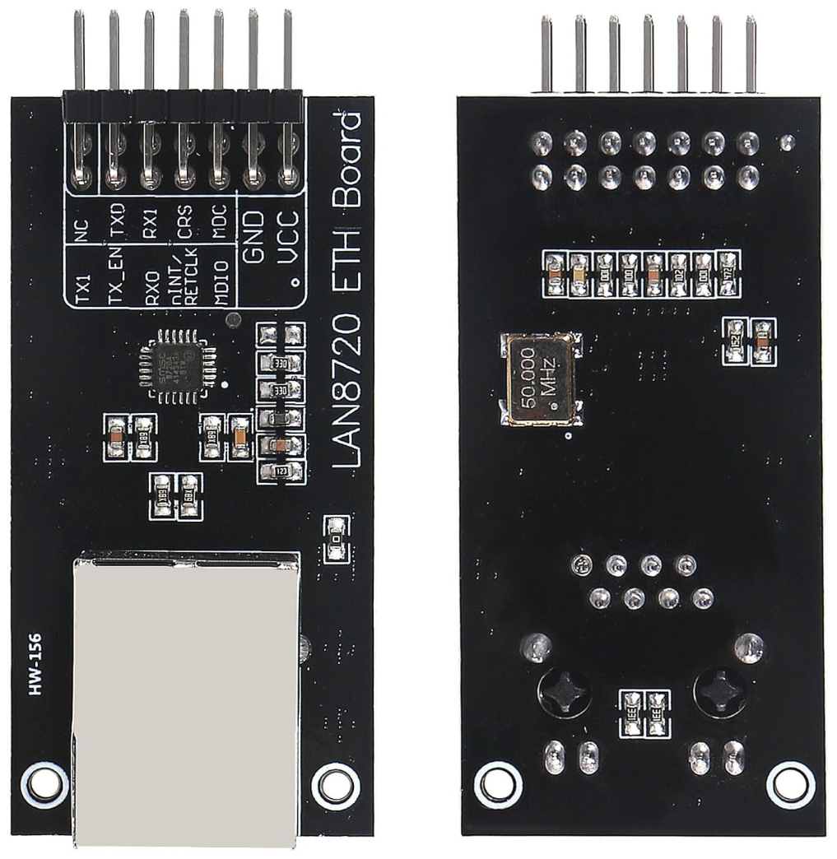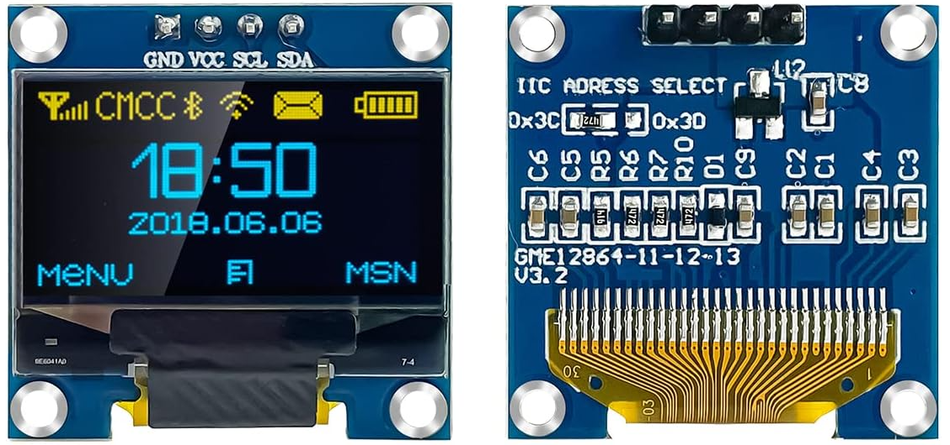

(LAN8720) (OLED)

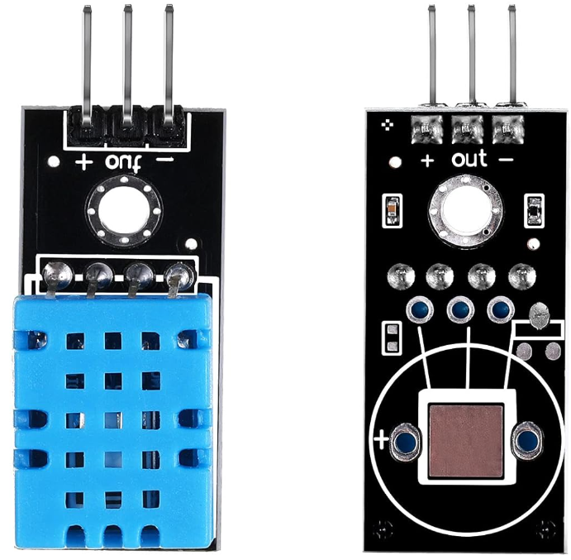 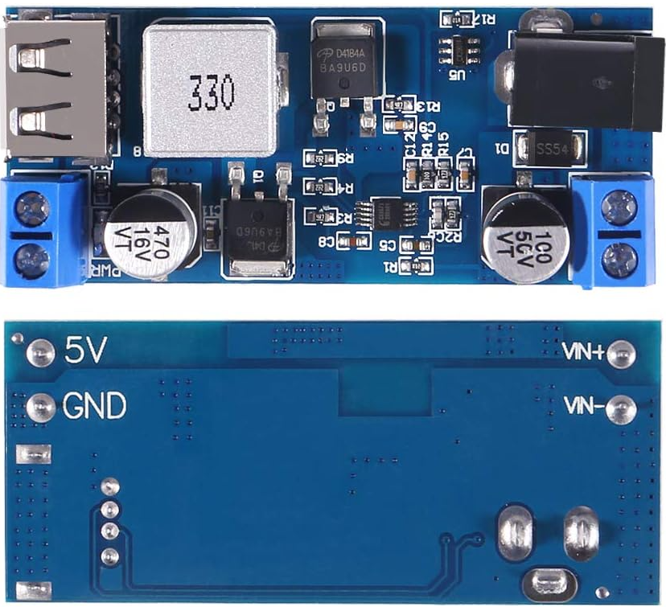

(DHT11) (Buck Converter)

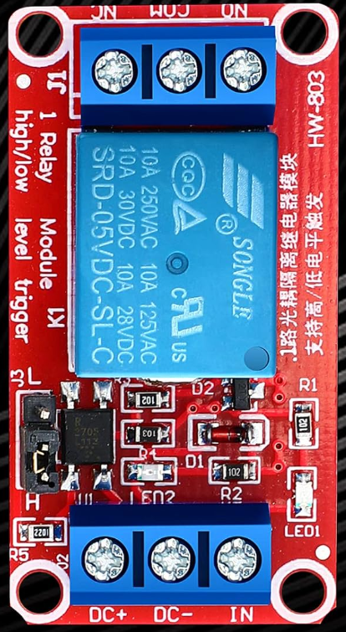 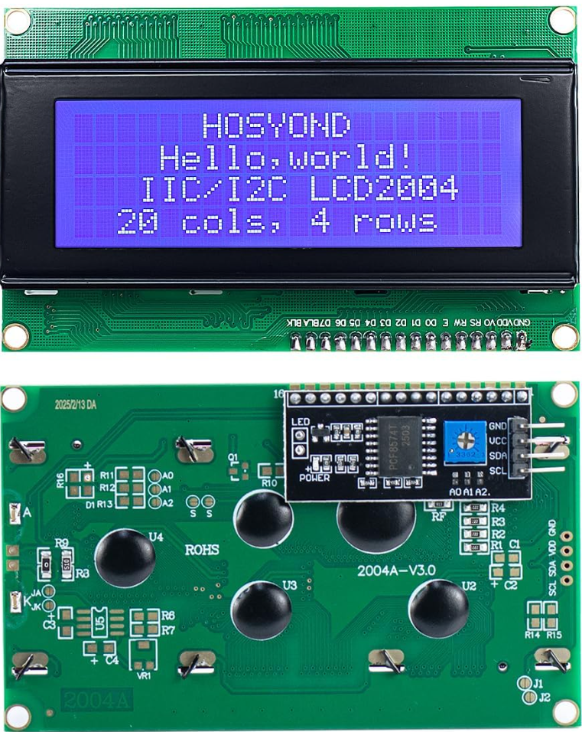

(5V Relay) (LCD2004)

Esp32-C6-Wroom to 38pin Breakout Board:

ESP32-GPIO 38 Pin Header ESP32-GPIO 38 Pin Header

|  |  |  |  |
| --- | --- | --- | --- |
| 3V3 | 3V3 | GND | GND |
| RST | EN | TX | P23 |
| 4 | SVP | RX | P22 |
| 5 | SVN | 15 | TX |
| 6 | P34 | 23 | RX |
| 7 | P35 | 22 | P21 |
| 0 | P32 | 21 | GND |
| 1 | P33 | 20 | P19 |
| 8 | P25 | 19 | P18 |
| 10 | P26 | 18 | P5 |
| 11 | P27 | 9 | P17 |
| 2 | P14 | GND | P16 |
| 8 | P12 | 13 | P4 |
| 5V | GND | 12 | PO |
| GND | P13 | GND | P2 |
| NC | SD3 | NC | P15 |

GAP-WiFi-c6 Pinout:

Function: GPIO 38 Pin

|  |  |  |
| --- | --- | --- |
| Garage door relay (to button) | 23 | RX |
| PIR Inside | 22 | P21 |
| PIR Outside | 21 | GND |
| Main garage door reed | 20 | P19 |
| Obstruction / safety beam | 19 | P18 |
| I²C SDA (OLED/2004/etc.) | 6 | P34 |
| I²C SCL | 7 | P35 |
| DHT11 data | 2 | P14 |
| Buzzer | 10 | P26 |
| 3V3 | 3V3 | 3V3 |
| 5V – on 3V3 side | 5V | GND |
| GND – Refer to above for other GND | GND | P13, P2, P16 |

GPIO MAP – ESP32-C6 DevKitC-1 (WiFi Panel

GPIO3   -> (free / future)

GPIO4   -> DHT11 Temperature/Humidity (1-wire)

GPIO10  -> Inside garage door reed (INPUT, pullup)

GPIO11  -> Outside garage door reed (INPUT, pullup)

GPIO16  -> Buzzer (OUTPUT, active)

GPIO20  -> Main garage door reed (INPUT, pullup)  [Primary door state]

GPIO21  -> PIR Outside (INPUT)

GPIO22  -> PIR Inside (INPUT)

GPIO23  -> Garage door relay (OUTPUT, momentary)

GPIO6   -> I2C SDA (LCD2004 / I2C bus A)

GPIO7   -> I2C SCL (LCD2004 / I2C bus A)

GPIO1   -> (free / future use)

Safe to use on ESP32-C6:

ADC: 0–6, 9  (currently unused)

General-purpose I/O (used here): 3,4,6,7,10,11,16,20,21,22,23

GPIO MAP & AVAILABLE PINS (ESP32-WROOM + LAN8720)

GPIO2   -> DHT11 Temperature/Humidity (1-wire)

GPIO4   -> Garage door relay (OUTPUT, momentary)

GPIO5   -> Buzzer (OUTPUT, active)

GPIO13  -> Inside garage door reed (INPUT, pullup)

GPIO14  -> Main garage door reed (INPUT, pullup)  [Primary door state]

GPIO16  -> Outside garage door reed (INPUT, pullup)

GPIO32  -> I2C SDA (OLED)

GPIO33  -> I2C SCL (OLED)

GPIO34  -> PIR Inside (INPUT-only, NO internal pullup)

GPIO35  -> PIR Outside (INPUT-only, NO internal pullup)

Ethernet (LAN8720 - reserved, do not repurpose):

GPIO17  -> RMII CLK_OUT (50 MHz via internal)  [WestTech – LAN8720 to ESP32 (Stable-Tested)]

GPIO18  -> MDIO

GPIO23  -> MDC

GPIO19  -> RMII TX0

GPIO22  -> RMII TX1

GPIO21  -> RMII TX_EN

GPIO25  -> RMII RX0

GPIO26  -> RMII RX1

GPIO27  -> RMII CRS

Boot/flash pins to avoid:

GPIO6..11 -> Flash pins (SDIO) — DO NOT USE

GPIO0, GPIO2, GPIO12, GPIO15 -> Boot strap pins; use with care

GPIO1 (TX0), GPIO3 (RX0)     -> Serial console; avoid unless you know the trade-offs

Actually available & recommended:

INPUT-ONLY (no internal pullups; use external 10k to 3.3V for NC sensors)

GPIO34, GPIO35, GPIO36(VP), GPIO39(VN)

    Typical uses: safety beam, extra door/window reeds, additional PIRs, dry-contact inputs

Usable with care (strap/LED caveats):

GPIO2  -> Strap + often onboard LED on some dev boards; must NOT be pulled low at boot.

      Here used for DHT11 (idles high, OK as long as wiring is clean).

GPIO15 -> Strap (usually pulled-down). Safer as OUTPUT; avoid external pull-up at boot.

GPIO0  -> Strap; must be HIGH at boot (LOW enters flash mode) — generally avoid for external buttons.

GPIO12 -> Strap; affects flash voltage; avoid connecting anything that could pull it up at boot.

Wiring assumptions for this version:

- Reeds: 13 (inside), 16 (outside), 14 (main door state)

- PIRs:  34 (inside), 35 (outside)

- OLED:  SDA=32, SCL=33, addr 0x3C

- DHT11: GPIO2